Modernize

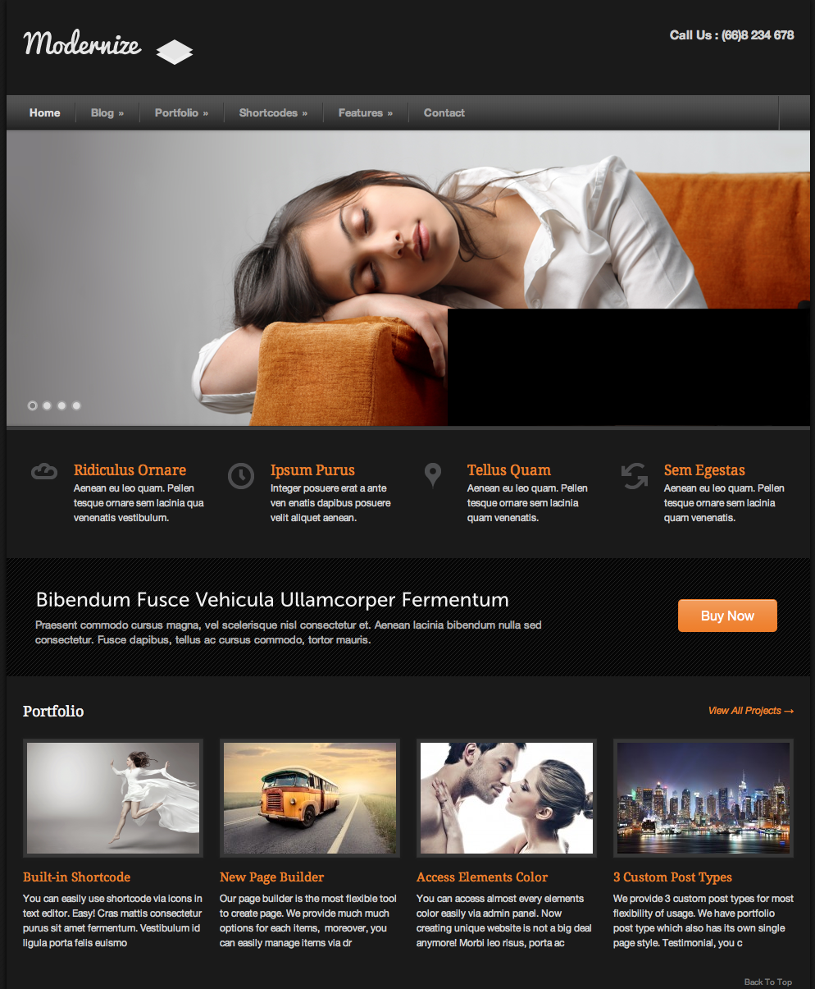Duplicate the web page below using HTML and CSS:

Requirements:

* All texts (except for the company logo) should be broken down to HTML/CSS.
* Buy Now should be a button or link but not image.

Notes:

* The pictures used are available for download [here](http://s3.amazonaws.com/General_V88/boomyeah/company_209/chapter_4214/handouts/chapter4214_7858_modernize.zip). You may also download the web page from [here](http://s3.amazonaws.com/General_V88/boomyeah/company_209/chapter_4214/handouts/chapter4214_7852_c-modernize.png).
* To prevent other students from copying your work, please make sure your code are not saved on GitHub or any file sharing site.
* To minimize score deduction, please make sure you upload the complete requirements (HTML, CSS, images).
* No need to create video demo for Yellow Belt exam.
* If you are having trouble uploading files on the Exam App, please DO NOT unlock another exam. Please email the file to remote-instructors@codingdojo.com and CC your instructor.